

1. **Created database of name kfc and then table of name tbl_publisher.**

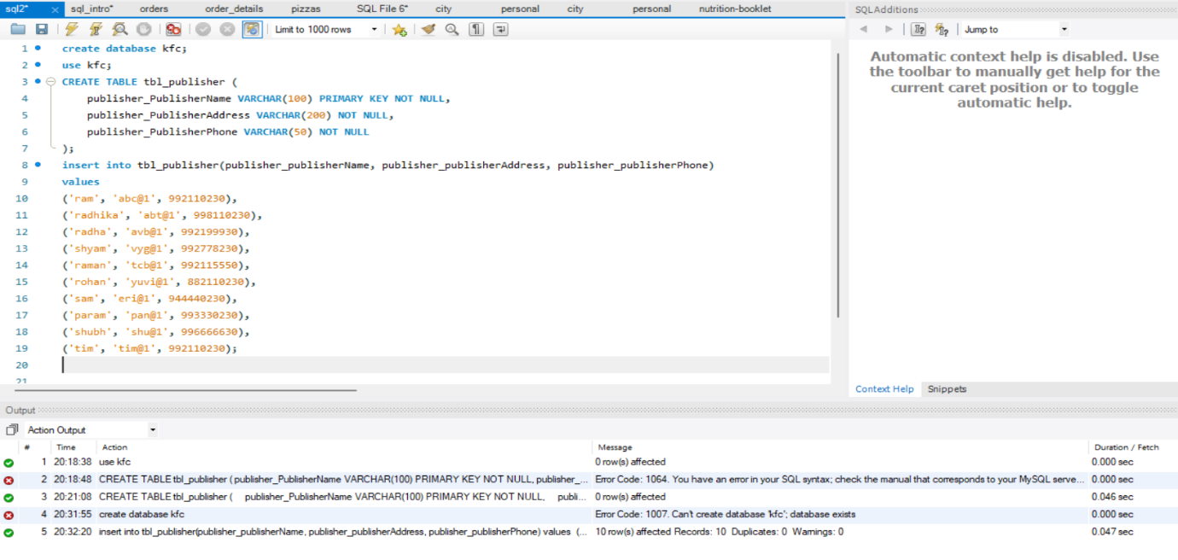

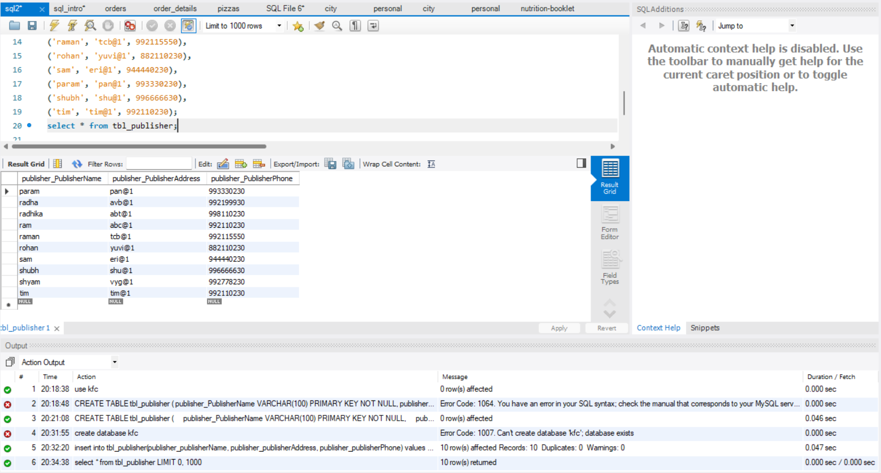

1. **Printing different publishers name and phone numbers to get insight easily.**

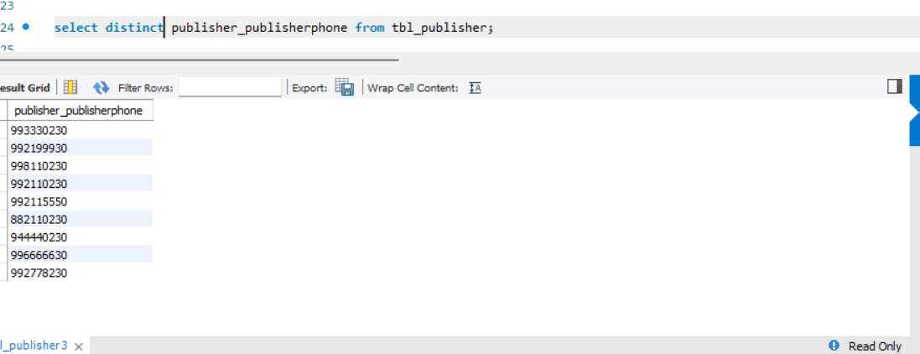

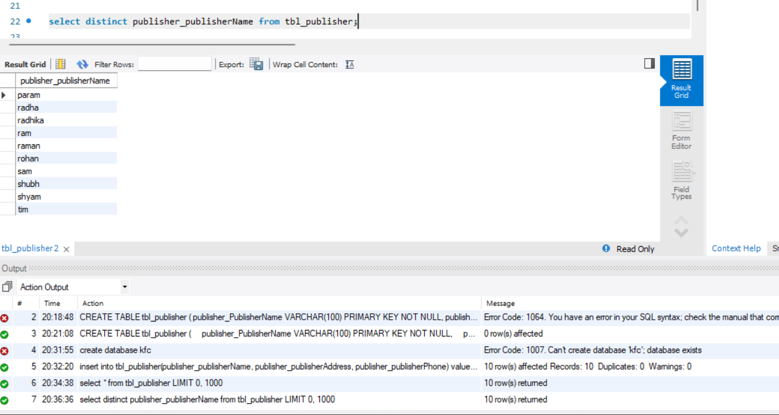

1. **Calculating the total number of publishers whose books have been present under the library using count keyword.**

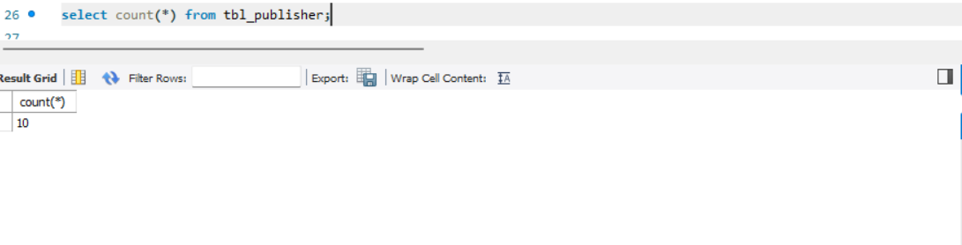

1. **Fetching for a particular / specific person with name tim.**

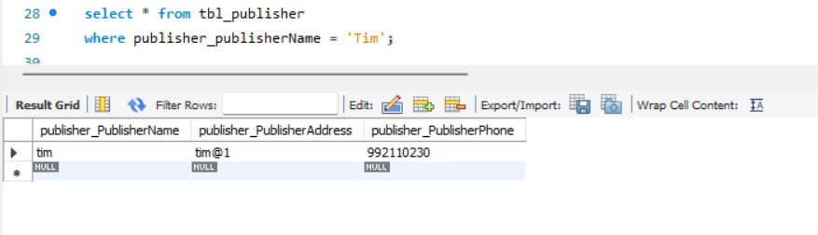

1. **Fetching the data of publishers whose phone number starts with 8.**

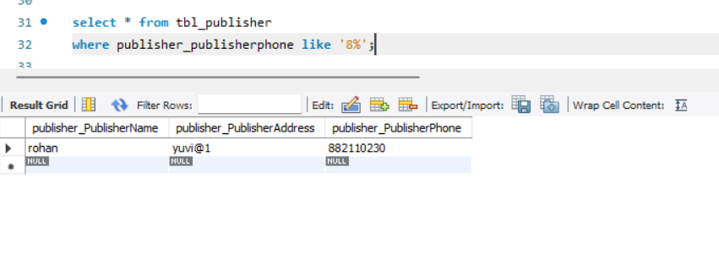

1. **Fetching the data of publishers whose name starts with letter ‘r’.**

